2019 PLEDGE SUMMARY

covid-19 update: From the front lines
March 27th, 2020

Hello Again, Friends of Central SC Habitat:

Wow! A lot has happened since our last communication. From work at home strategies to social distancing, things that would never have been considered in the past, are now becoming a part of our day-to-day realities. You may also wonder exactly what role that Habitat for Humanity, especially, Central SC Habitat, plays in a world-wide pandemic. The answer may really surprise you.

First, we play a critical role by having a presence at SC Emergency Management’s State Emergency Operations Center (SEOC), assisting with coordinating donations from throughout the country and working to ensure that they get to where they are most needed. This presence helps us to anticipate community needs and to strategically plan for Habitat’s on-going role in this crisis.

Next, we are also opening our warehouse resources to donate Personal Protective Equipment (PPE) like masks, rubber gloves, and coveralls to be used by healthcare and first responders, not only to protect themselves, but also to help prevent the spread of the Novel Coronavirus in their communities. Yesterday, we were able to contribute PPE to both Lancaster and Spartanburg Counties to help with their response to the crisis. These donations help make resources available to organizations where supplies may be low or non-existent.

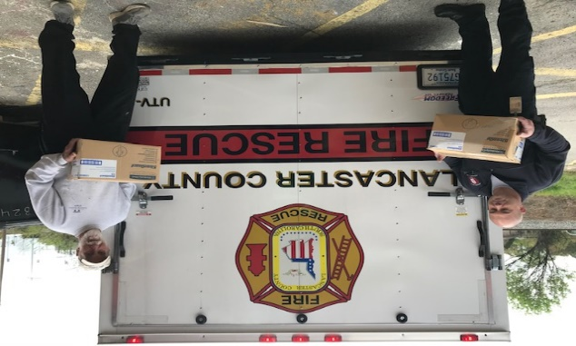
Central SC Habitat Executive Director Roy Kramer helps load 680 hazmat suits to be used in Lancaster County’s COVID-19 response.

Also, despite suspending all volunteer projects, our Habitat team is still hard at work. We are dedicated to taking care of those in our Homeowner and Neighborhood Revitalization programs, especially those currently in the building process. We are also working on plans on how to quickly ramp-up our building operations once we receive the “all clear’ from Emergency Management. As we continue to monitor the latest developments regarding COVID-19, health and safety of our families, staff and volunteers remains our number one priority, so please bear with us as we navigate this journey together.

How Can YOU Help?

Most families, including those served by or who work for Central SC Habitat are worried right now about how long their income stream will last- if they haven't already lost it. Imagine if you were just getting by- and now you've been told to stay home with no pay-check because your job is not essential.
During this trying time, any donation, no matter how big or how small, will help us to continue to serve those who need our help both now and, in the months, to come. There are several ways to support our capacity to continue to serve South Carolina’s emergency response:

$250 Provides funding for two mission essential persons to continue to serve for one day.
$500 Supports the Central SC Habitat food pantry, providing approximately 290 meals to Habitat families in need.
$1,000 Provides funding for 50 A35 PPE or other supplies needed to restock Habitat inventory depleted by emergency response.
$5,000 Provides full staff levels for Habitat disaster critical staffing for 1 ½ days.
Other Gift levels are also welcome.
Contributions can be made:
- On-line at habitatcsc.org/donate. Please indicate “COVID-19” in the Comments Section.
- Contact Karl Weeks at kweeks@habitatcsc.org or 803-252-3973 with credit card information.
- Mail a check to: Central SC Habitat for Humanity, 209 S. Sumter Street, Columbia, SC 29201.

Thank you to everyone who have already reached out to help us during this time. We pray for your safety and health during this time and thank you for your prayers and support for our mission.

Blessings, be safe, check on your neighbors, and wash your hands. Thanks, and we can’t do this without YOU!
Roy Kramer and Team
Central SC Habitat for Humanity

Thank You!
209 S. Sumter St., Columbia, SC 29201 / 803-252-3570 / www.habitatcsc.org

