2019 PLEDGE SUMMARY

covid-19 update: From the front lines
April 24th, 2020

Hello Again, Everyone!

It’s time once again time to give you an update on how Central South Carolina Habitat for Humanity is working through the challenges of COVID-19 and its effects on our operations. As we said in the last newsletter, even though we have suspended all volunteer projects, our Construction and Neighborhood Revitalization Teams are hard at work on the two build sites on Jessie Street in Lexington, in anticipation of the go-ahead from Government officials to resume normal activities. The closer to completion of these homes that we can be, even with social distancing, the sooner our well deserving families can move into their “forever home.”

As of last week, we have already distributed over 5,000 pieces of PPE worth almost $50,000 to healthcare organizations, disaster managers, and first responders. This PPE included 4,200 Hazmat suits, 1,000 hand sanitizer safety kits for law enforcement, plus a variety of other supplies. Organizations served by this response include PRISMA Health, Lexington Medical Center, Self Regional Medical Center, Emergency Management Offices in Spartanburg, Chester, Lancaster, Laurens Counties, as well as SC Department of Corrections (SCDOC) and SC Department of Health and Environmental Control (SCDHEC). Hand sanitizer kits have been received by SC Highway Patrol, Cayce Public Safety, Richland County Sheriff’s Office, and the Dillon County Long-Term Recovery Group.

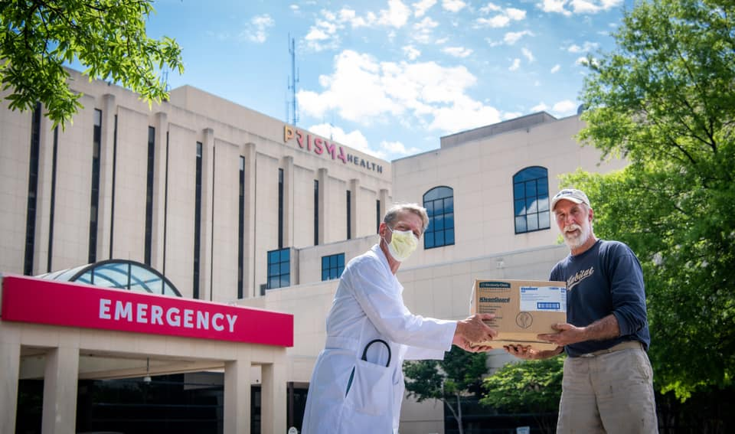
Central SC Habitat Executive Director Roy Kramer with PRISMA Health’s Dr. David Ford dropping off Hazmat Suits to Prisma Health-Midlands as part of our COVID-19 response.

As you can see, your Habitat team is still very hard at work. We are dedicated to taking care of those in our Homeowner and Neighborhood Revitalization programs, especially those currently in the building process. We are also working on plans on how to quickly ramp-up our building operations once we receive the “all clear’ from Emergency Management. As we continue to monitor the latest developments regarding COVID-19, health and safety of our families, staff and volunteers remains our number one priority, so please bear with us as we navigate this journey together.

How Can YOU Help?

Most families, including those served by or who work for Central SC Habitat are worried right now about how long their income stream will last- if they haven't already lost it. Imagine if you were just getting by- and now you've been told to stay home with no paycheck because your job is not essential. Or picture a warehouse, once overflowing with goods and supplies, now with bare shelves and in need of donations of food for our food pantry or building supplies for our Building and Neighborhood Revitalization Programs.
..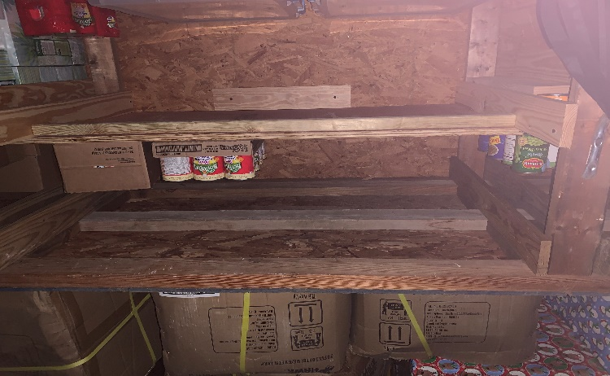

During this trying time, any donation, no matter how big or how small, will help us to continue to serve those who need our help both now and, in the months, to come. There are several ways to support our capacity to continue to serve South Carolina’s emergency response:

In-Kind Gifts:
-Hand Sanitizer for the ReStore and for Habitat Operations
-Surgical or N95 face masks for staff when working with the public
-Nitrile Gloves (Sizes Medium, Large, and Extra Large)
-Disinfectant wipes to clean frequently touched surfaces

Financial Support (93 cents of every dollar goes back into the community):
$100 Provides the material for 33 hand sanitizer kits for staff, clients, and first responders.
$250 Provides funding for two mission essential persons to continue to serve the community for one day.
$500 Supports the Central SC Habitat food pantry, providing approximately 290 meals to Habitat families in need.
$1,000 Provides funding for 50 A35 PPE or other supplies needed to restock Habitat inventory depleted by emergency response.
$5,000 Provides full staff levels for Habitat disaster critical staffing for 1 ½ days.
Other Gift levels are also welcome.
Contributions can be made:
- On-line at habitatcsc.org/donate. Please indicate “COVID-19” in the Comments Section.
- Contact Karl Weeks at kweeks@habitatcsc.org or 803-252-3973 with credit card information.
- Mail a check to: Central SC Habitat for Humanity, 209 S. Sumter Street, Columbia, SC 29201.

Thank you once again to everyone who have already reached out to help us during this time. We pray for your continued safety and health during this time and thank you for your prayers and support for our mission.

Blessings, be safe, check on your neighbors, and wash your hands. Thank you again for your partnerships, because we can’t do this without YOU!
Roy Kramer and Team
Central SC Habitat for Humanity

Thank You!
209 S. Sumter St., Columbia, SC 29201 / 803-252-3570 / www.habitatcsc.org

